

UNIVERSITY OF PETROLEUM AND ENERGY STUDIES
DEHRADUN

CYBER THREAT INTELLIGENCE

LAB 2 Threat Intelligence Feeds & Portals

MTECH-COMPUTER SCIENCE
ENGINEERING
CYBER SECURITY AND FORENSICS

Name: Jigesh Sheoran
SAP ID: 5090025428

Objective 1 — Threat feeds & pivots

A) ThreatView (daily 23:00 UTC high-confidence feeds)
- Open ThreatView → download latest domain/IP/URL/hash feeds.
- Pick 3–5 IOCs (a mix of domain, IP, hash). Note the feed timestamp.
- Log them in the template’s table (IOC Type, Value, Feed URL/Name, Timestamp, Notes).
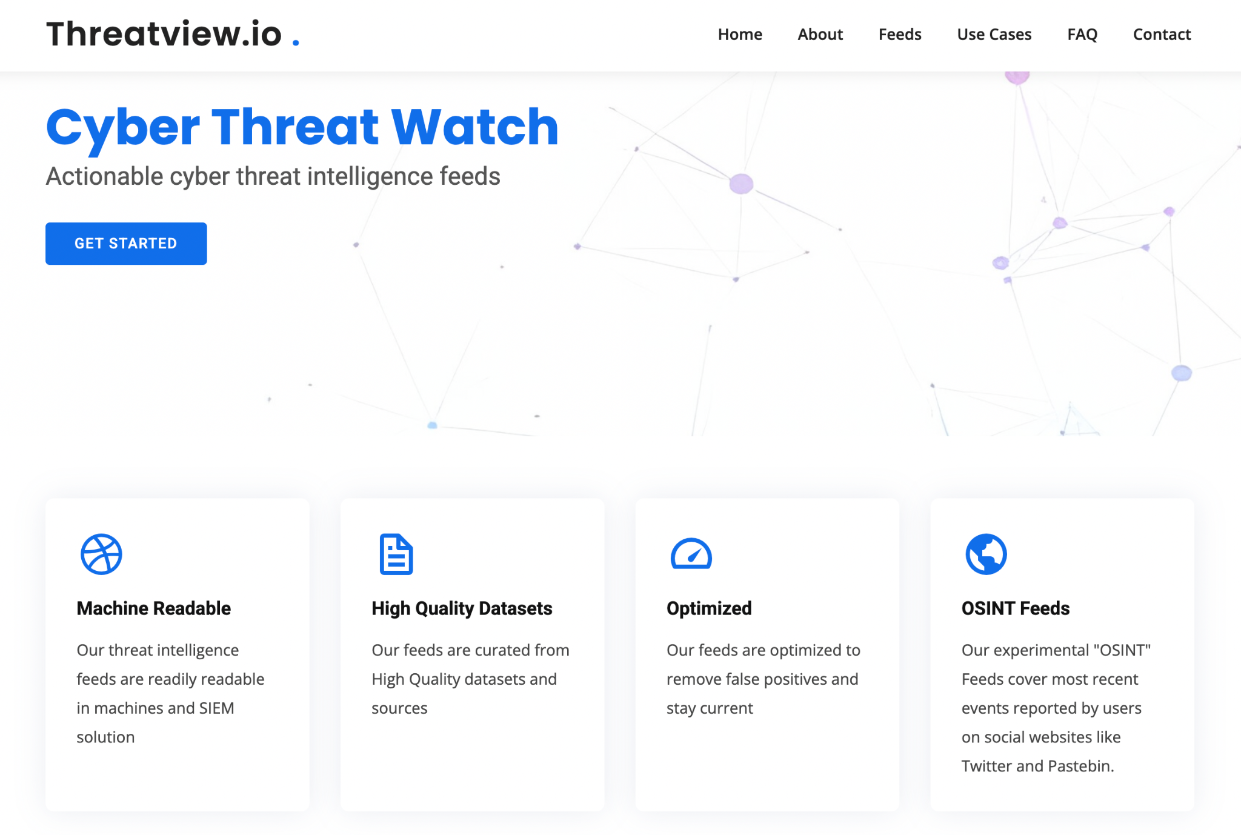
An Indicator of Compromise (IOC) is a part of forensic data —such as a file hash, IP address, domain, or log entry—that signals potential malicious activity, suggesting that a system or network may have been breached / compromised.
OSINT Threat Feed – basically it gathers malicious IOCs from open sources like Twitter, Pastebin, and other public platforms.
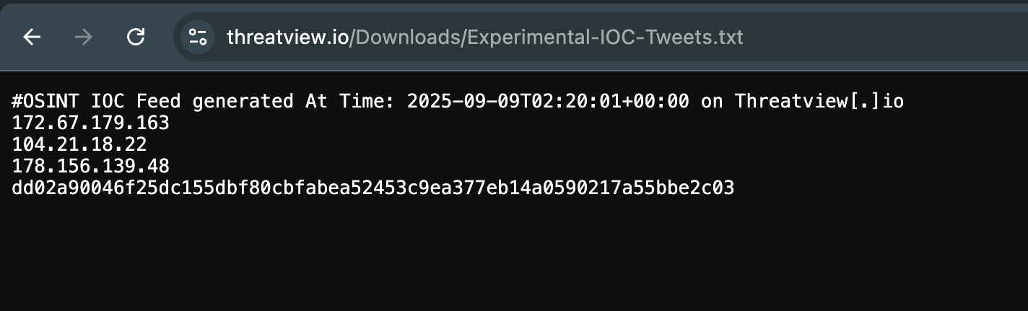
C2 Hunt Feed – this feed basically points out infrastructure that’s hosting Command-and-Control (C2) servers, which researchers find through active threat hunting.
I checked the C2 Hunt Feed on ThreatView.io and saw a list of IPs/domains flagged as active C2 servers. The feed gave me an idea of how attackers set up and use C2 infrastructure to control infected machines. I realized that these feeds are important for defenders, because if you can detect and block these C2 endpoints, you can break the attacker’s communication chain and reduce the impact of an attack.
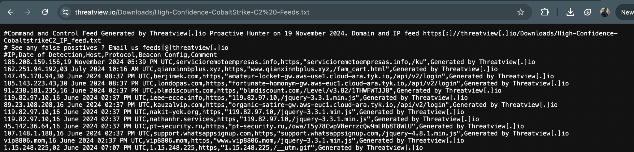

IP Blocklist : Malicious IP Blocklist for known Bad IP addresses
I checked the IP Blocklist on ThreatView.io and saw a collection of IPs marked as malicious. These are basically known bad IPs linked with malware, spam, or C2 activity. My takeaway was that such blocklists are really helpful in monitoring and defense, since if my system talks to any of these IPs, it’s a clear red flag.
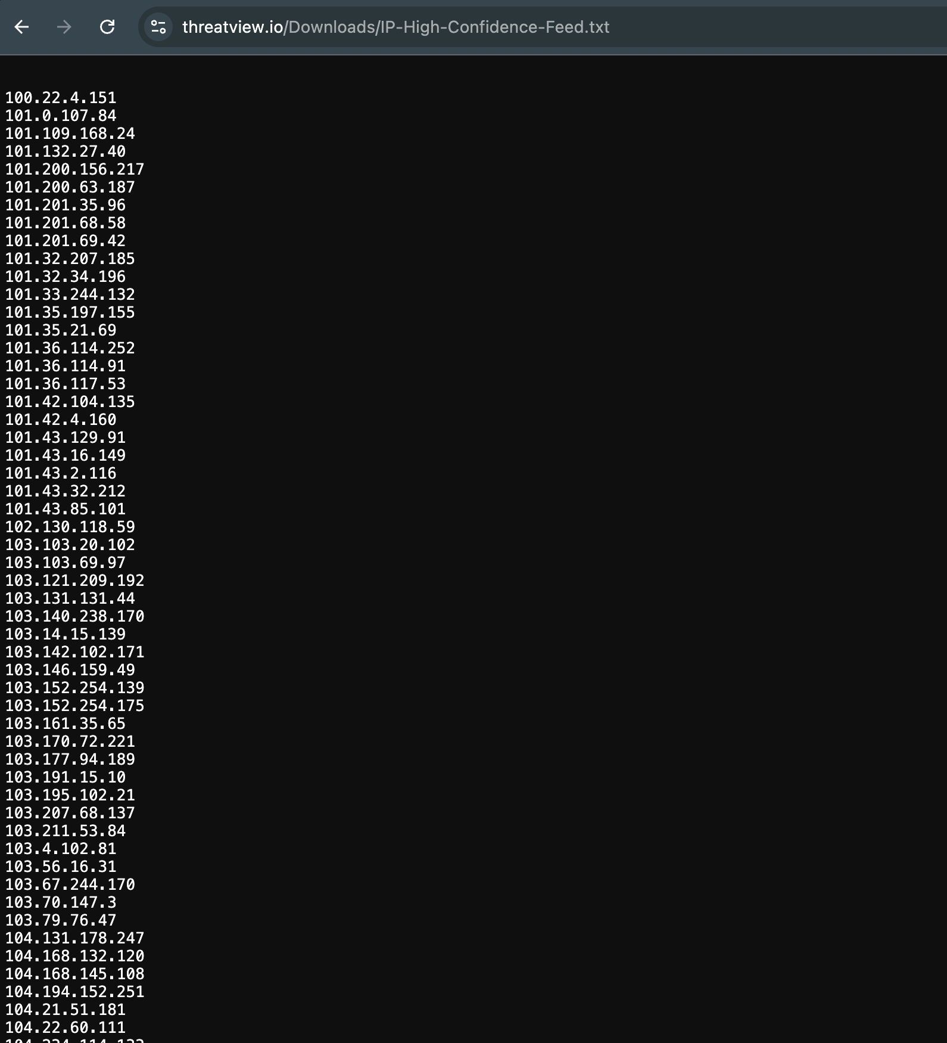

Domain Blocklist : Malicious Domains identified for phishing/ serving malware/ command and control
I checked the Domain Blocklist on ThreatView.io and found domains marked as malicious, used for phishing, malware hosting, or C2 activity. It made me realize how attackers use fake but convincing domains to fool users. The key learning was that keeping track of such blocklists helps defenders block dangerous traffic early and reduce risks.

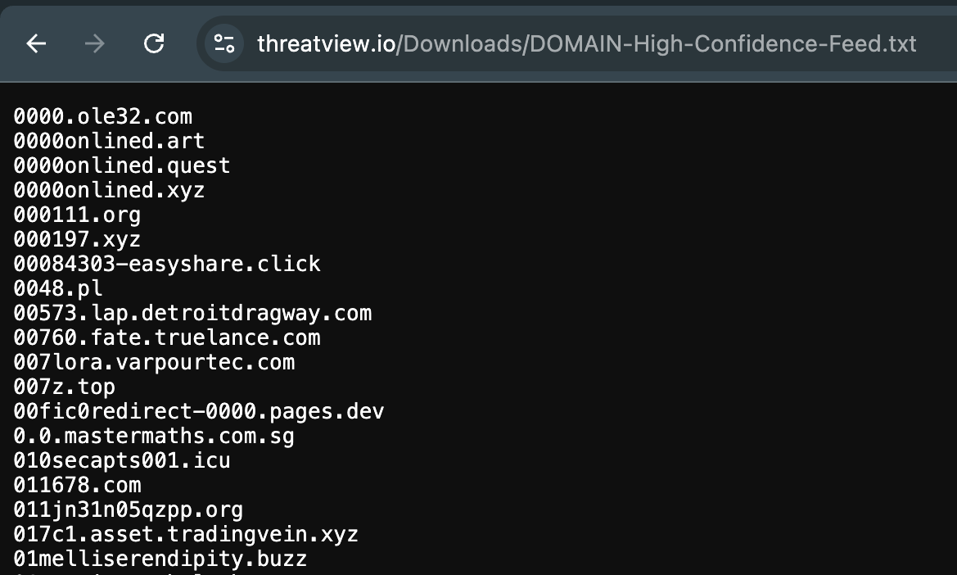

MD5 Hash Blocklist : MD5 hashes of malicious files or associated with - malware, ransomware, hack tools, bots etc.
Checked the MD5 Hash Blocklist on ThreatView.io and saw hashes of files linked to malware, ransomware, hack tools, and bots.
It showed me how file hashes can be used like fingerprints to identify bad files. I learned that checking local file hashes against such feeds helps in spotting infections quickly, even if attackers try to rename the files.
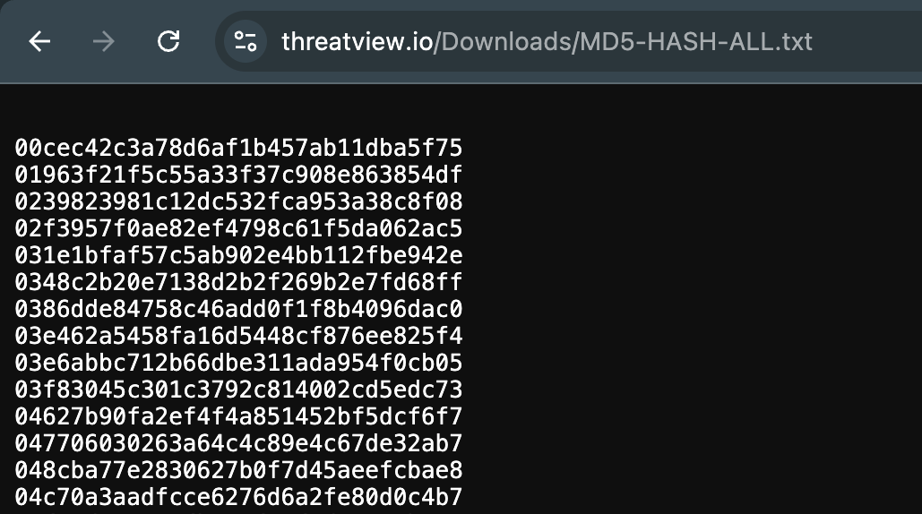

URL Blocklist : Malicious URL's serving malware, phishing, botnets and C2
After checking URL Blocklist what stood out was that many of these looked normal but had hidden malicious links. I learned that tracking malicious URLs is important because attackers use them to deliver payloads and trick users, so blocking them adds another layer of defense.
Most of these URLs are hosted in Russia.
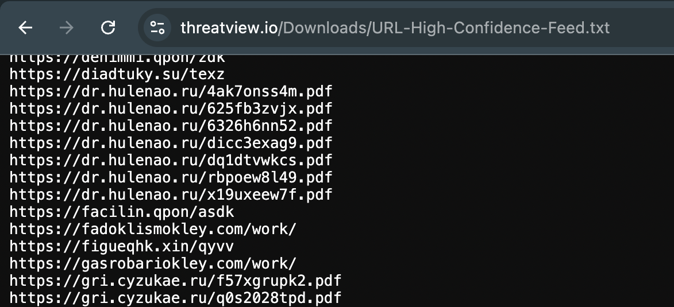

Bitcoin Address Intel : Bitcoin addresses identified to be linked with malicious activity
After checking the Bitcoin addresses on Threatview, I realized that even cryptocurrency addresses can act as IOCs. I learned that by tracking these addresses, defenders can connect financial activity back to cybercrime and strengthen investigations.
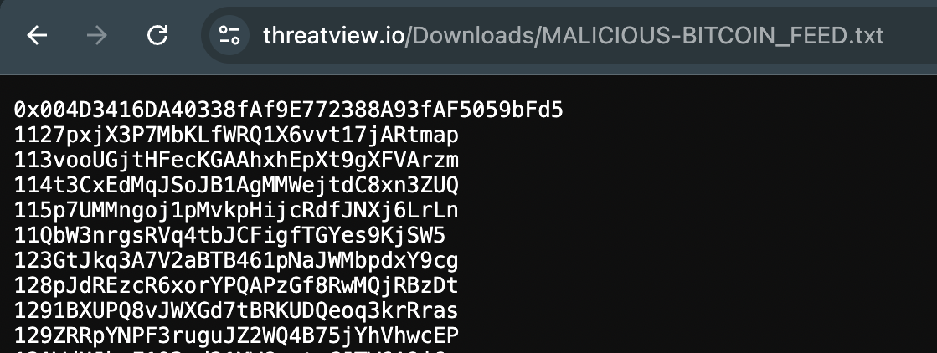

SHA File Hash Blocklist : SHA hashes of files known or linked with malware execution
This showed me how SHA hashes work like unique fingerprints for files, making detection stronger than MD5. I learned that using SHA hash feeds helps in spotting malware more accurately and prevents attackers from bypassing detection just by renaming or tweaking files.
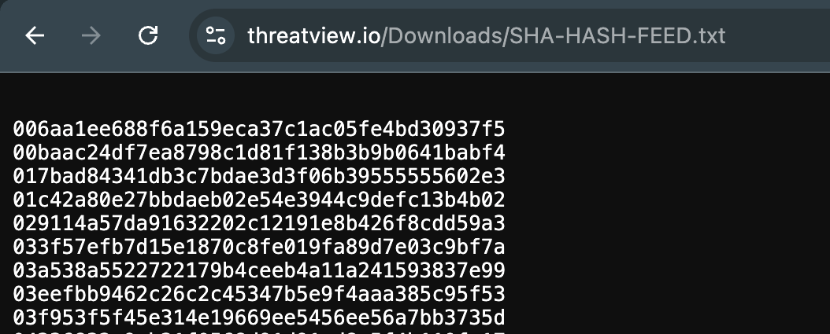

B) ThreatMiner (single-pane IOC research)
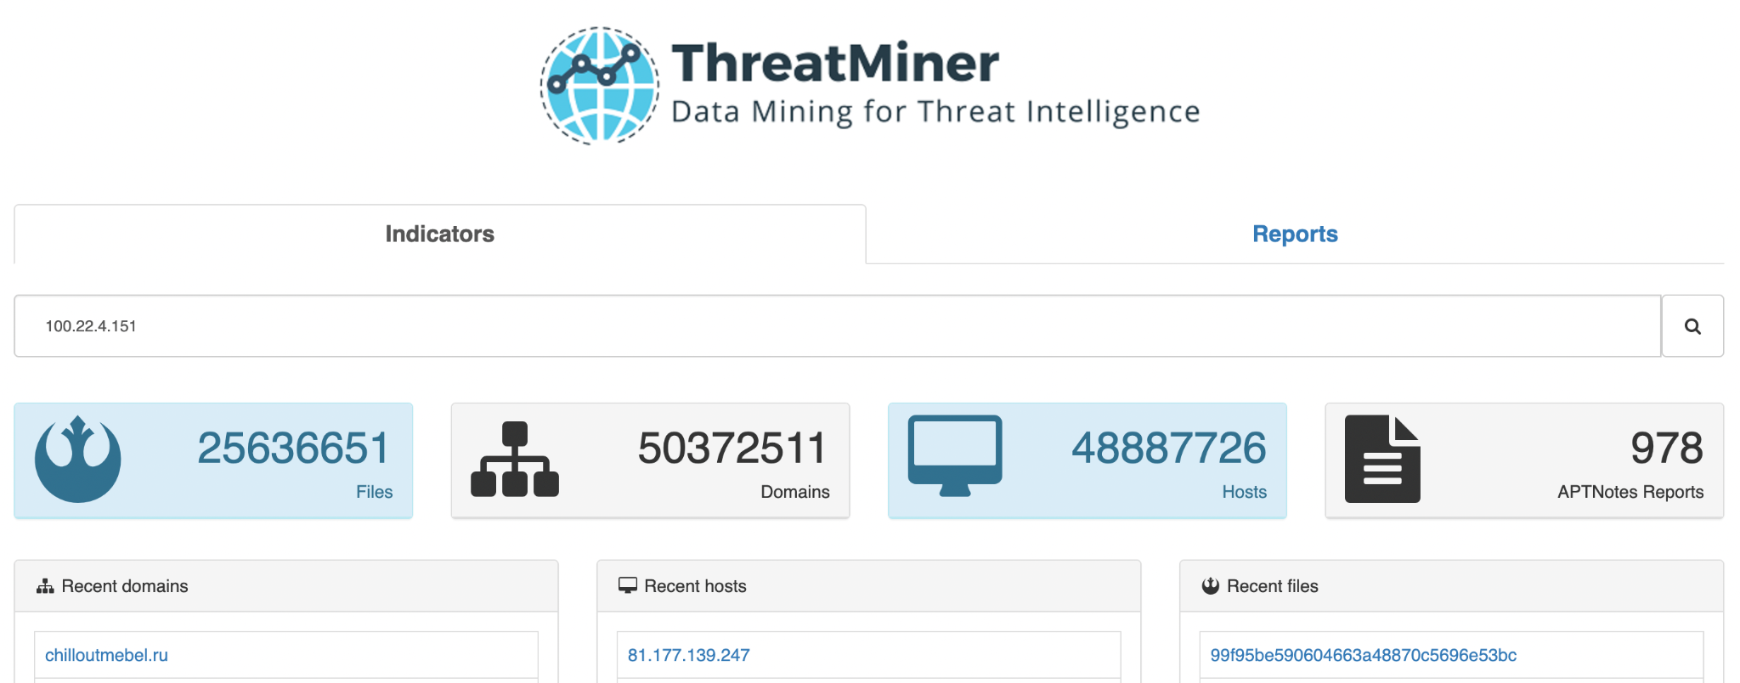
I selected the IP 100.22.4.151 from the latest ThreatView IP Blocklist feed and searched for it on ThreatMiner.
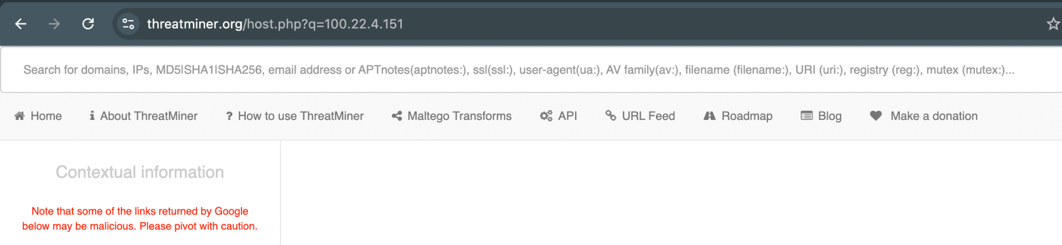
The query returned no indexed data, meaning there were no associated domains, hashes, samples, or threat reports linked to this IP in ThreatMiner’s datasets. The platform only showed that no results were available for this IOC.
A “no result” can mean the IP is newly flagged, low-profile, or not yet correlated across multiple OSINT sources.
While working with ThreatView and ThreatMiner, I noticed a mismatch between the two platforms. ThreatView publishes fresh threat feeds on a daily basis, but when I took multiple IOCs (around 15 queries) from those feeds and searched them in ThreatMiner, almost all of them returned blank responses. This indicates that ThreatMiner does not immediately ingest or index the latest threats reported by ThreatView.
My main takeaway is that relying on a single TI platform can create blind spots, and analysts should always cross-check IOCs across multiple feeds and tools for complete visibility.

Objective 2 — VirusTotal multi-engine analysis
Targets you must cover: at least one IP, one domain, one file, and one hash.
Recommended sources from the lab sheet:
- Malware file(s): GitHub LJ9859 “Malware-Database” (ZIP password 1337) — upload cautiously.
- Hash list: Bitdefender Metamorfo sample hashes (analyze by hash).
- Phishing URLs: Kaggle Malicious URLs dataset (take a small subset).
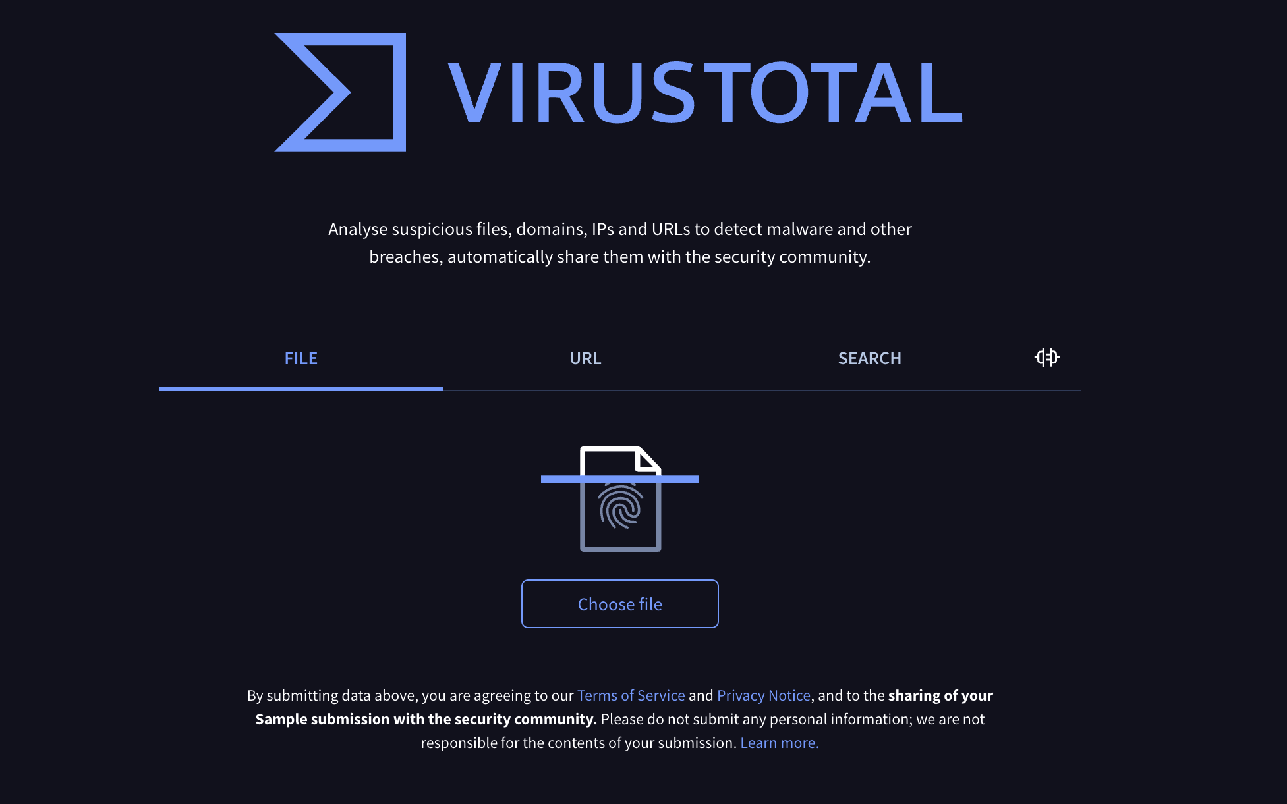
Steps: 1
pArasIte - “I tested my custom malware (‘Infect.cpp’ from my Parasite repo: https://github.com/sheoraninfosec/Parasite) on VirusTotal.
Out of 62 engines, none flagged it as malicious. This was an important observation because it showed me that fresh or custom malware can easily bypass signature-based detection. Just because VirusTotal shows 0/62 doesn’t mean the file is safe. I learned that defenders must use multiple approaches like sandboxing and behavioral analysis, not just VirusTotal, to detect new threats.
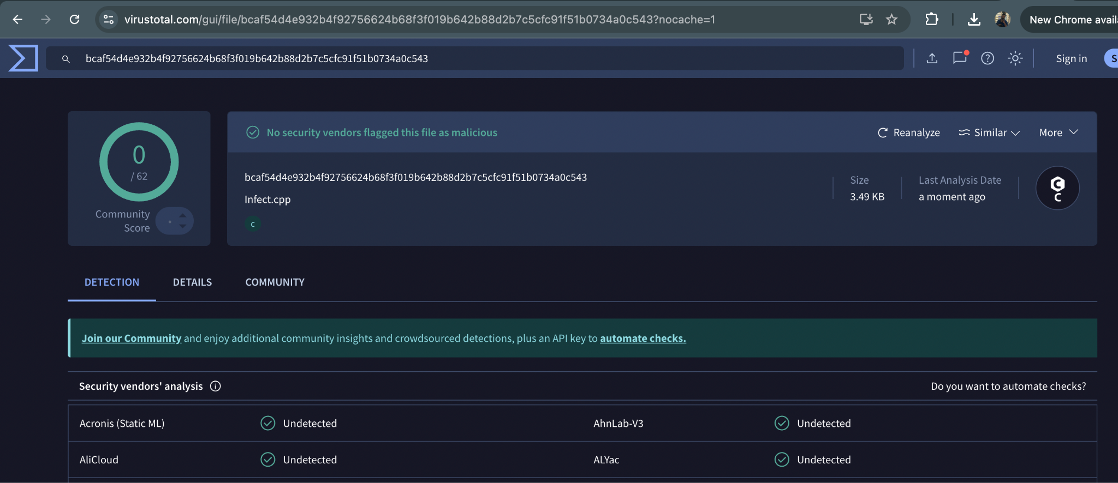
2. Working with Hash - malware-ioc
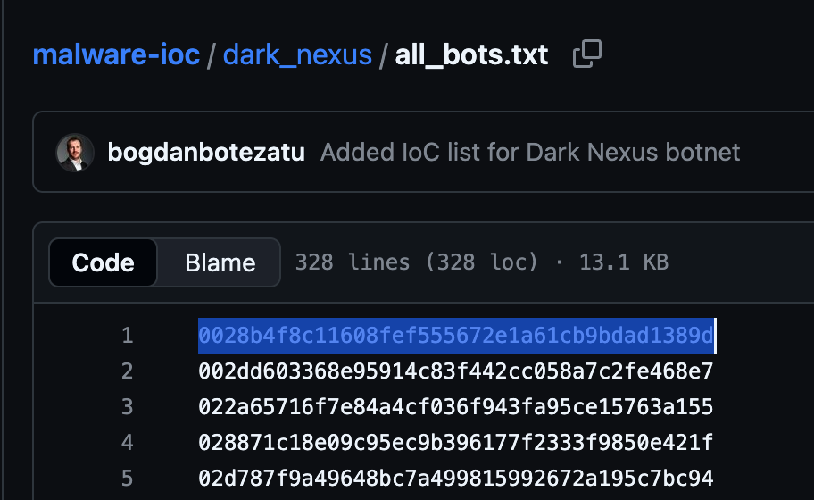
“For step 2, I took a malware sample from the Bitdefender Malware IOC database (https://github.com/bitdefender/malware-ioc) and uploaded its hash to VirusTotal.
Out of 64 antivirus engines, 40 flagged it as malicious. This confirmed that the sample is widely recognized by existing AV signatures.”

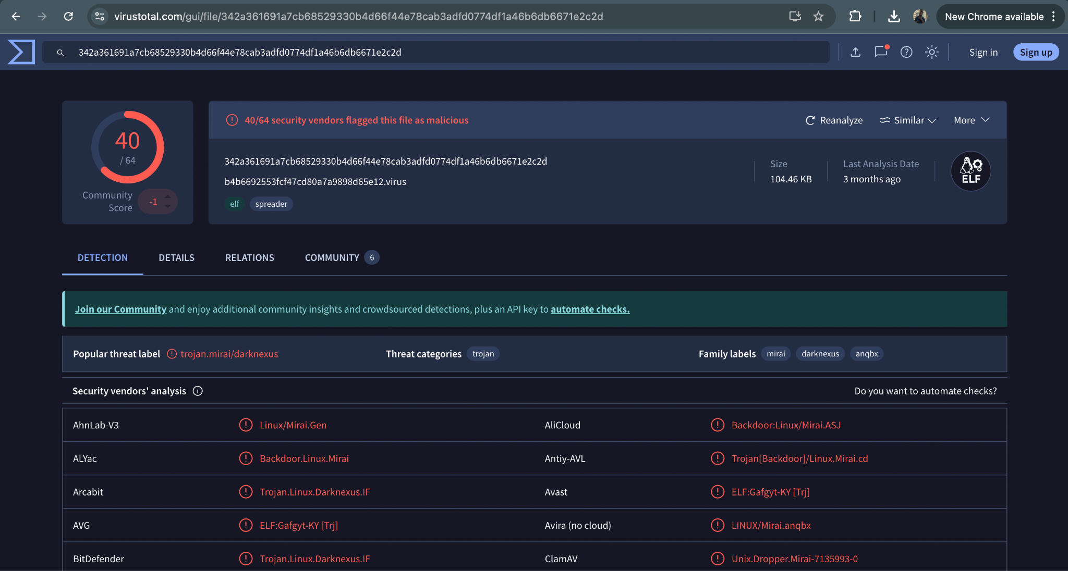
3. “For step 3, I tested a phishing URL sample (br-icloud.com.br) from the Kaggle dataset (https://www.kaggle.com/datasets/sid321axn/malicious-urls-dataset) on VirusTotal. Out of 95 engines, 12 flagged it—with 5 identifying it as phishing and 7 as malware. This shows that the URL is partially recognized by existing security tools.”
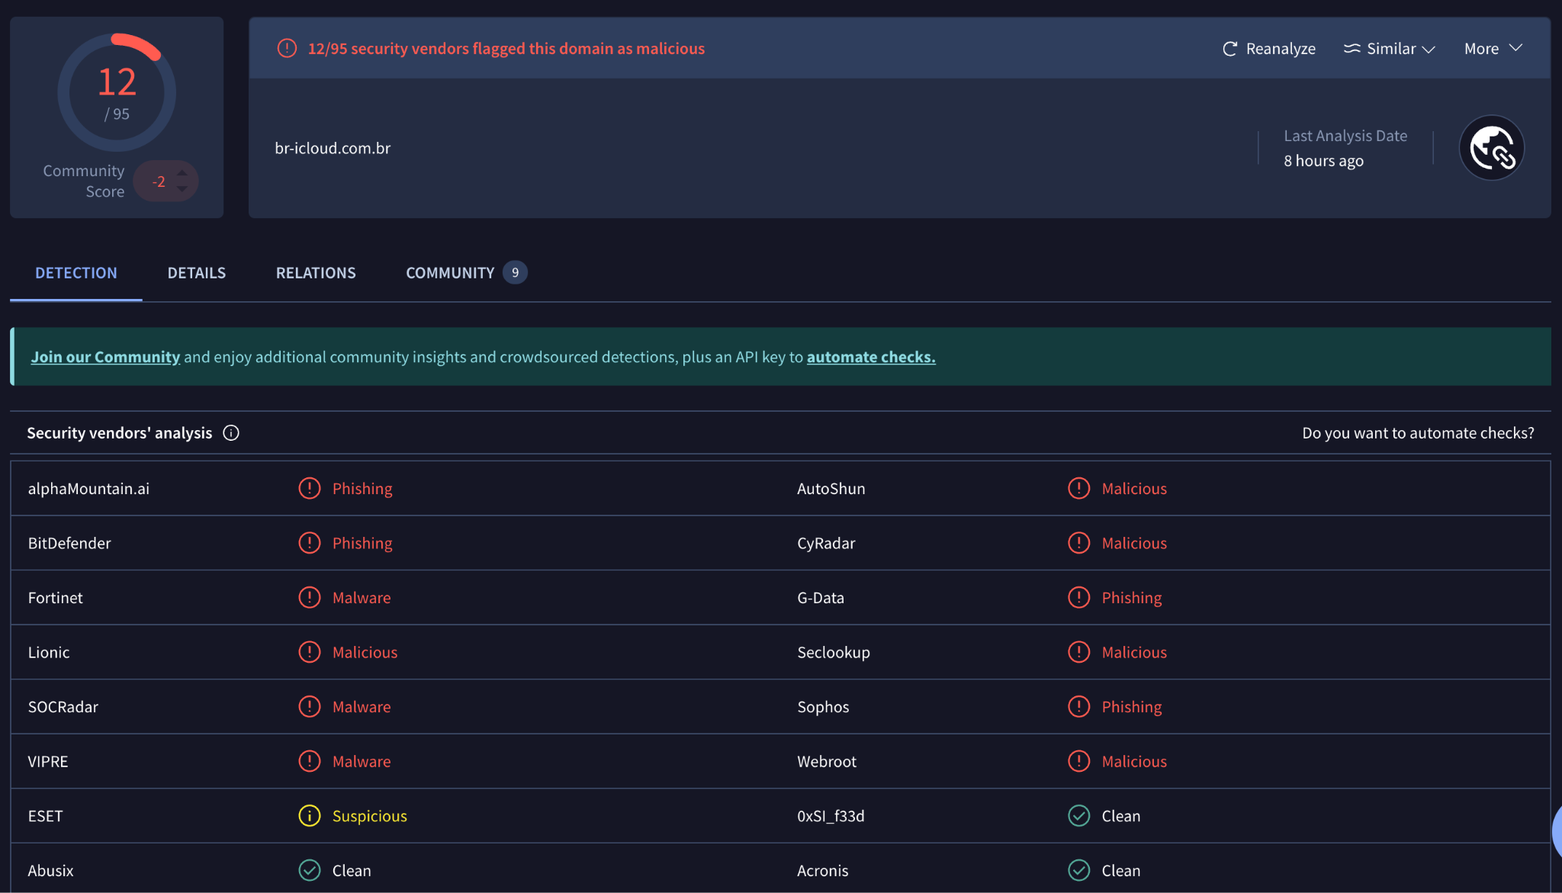

Observation:
My main observation is that phishing URLs are not always consistently detected across antivirus engines. While some engines recognized it, others didn’t, which highlights the limitations of relying completly on signature-based detection. It reinforced the importance of using multiple detection strategies, such as reputation-based systems, URL analysis, and behavioral monitoring, to identify phishing threats effectively.
4. Domain Analysis - 007z.top
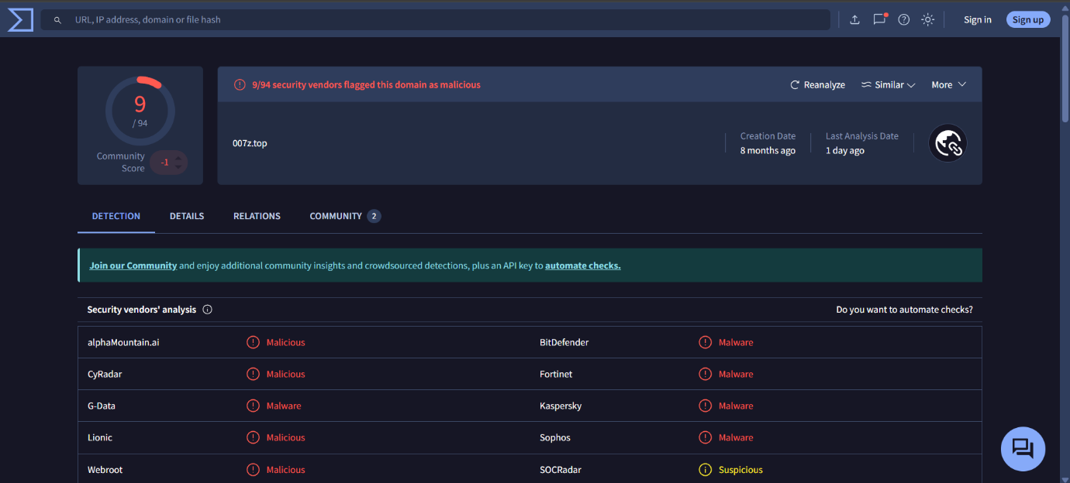
For step 4, I analyzed the domain 007z.top on VirusTotal. Out of 94 engines, 9 flagged it as malicious. Even though only a fraction of the engines detected it, following the precautionary principle, we consider the domain potentially harmful.”
Observation:
“My main observation is that even a single detection is enough to treat a file, URL, or domain as malicious. Some malicious domains may evade many security engines, so relying only on signature-based detection is risky. This emphasizes the need for multi-layered analysis, including reputation checks, behavioral monitoring, and heuristic scanning, to catch emerging threats effectively.

Objective 3 — AlienVault OTX: “most active malware” (last 7 days)
- In OTX, use Dashboard/Browse and filter to the last 30 days.
- Identify the most active malware/family (by pulse activity/recency).
- Open its relevant pulses and capture: adversary (if any), affected industries/regions, MITRE ATT&CK techniques, and the key IOCs (IPs, domains, file hashes, C2s).
- Summarize in the “OTX 7-day Malware Summary” table; add links to the pulses and screenshot the pulse page/IOC list.
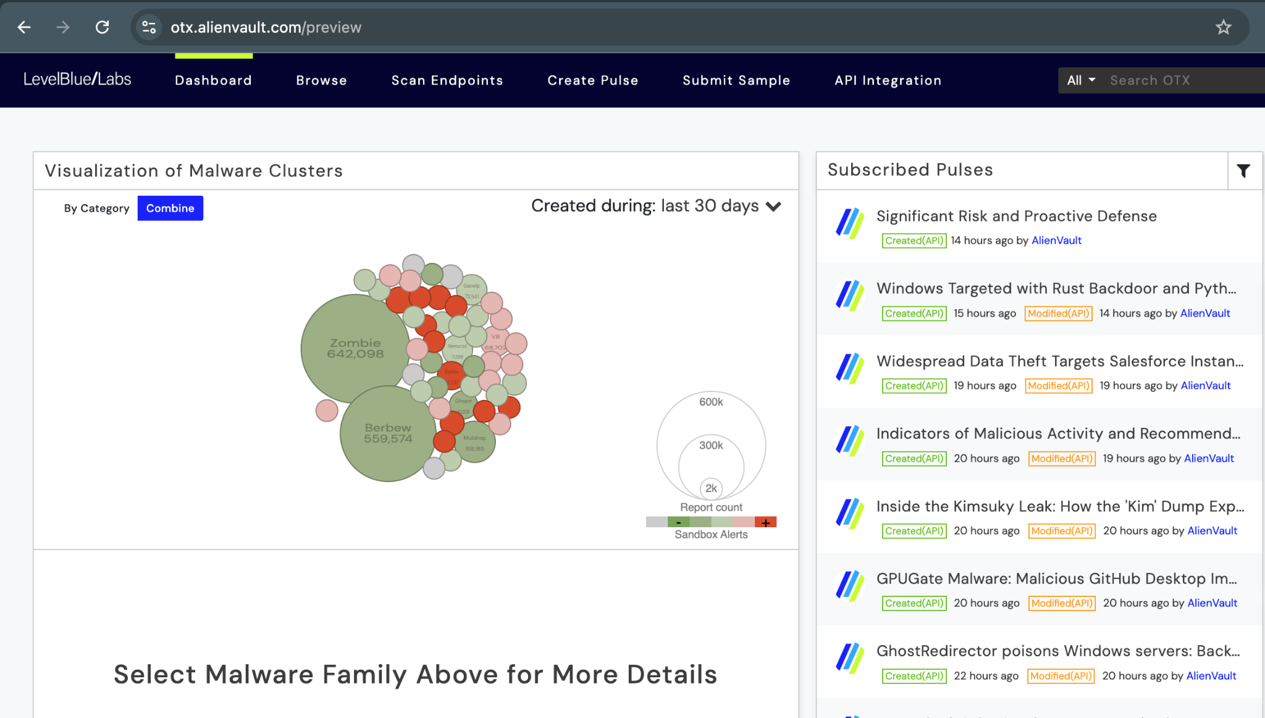
Analysis for past 30 days
Backdoor : Berbew /Win32 - 559,574 Count
Description: Berbew is a highly active backdoor malware family. Backdoors like Berbew provide attackers with persistent access to infected systems, bypassing standard authentication mechanisms.
Impact: Berbew can be used for data exfiltration, remote command execution, and lateral movement across compromised networks.
Recent Activity: Current threat intelligence pulses indicate Berbew is involved in espionage and financial theft campaigns, targeting both enterprises and individual users.
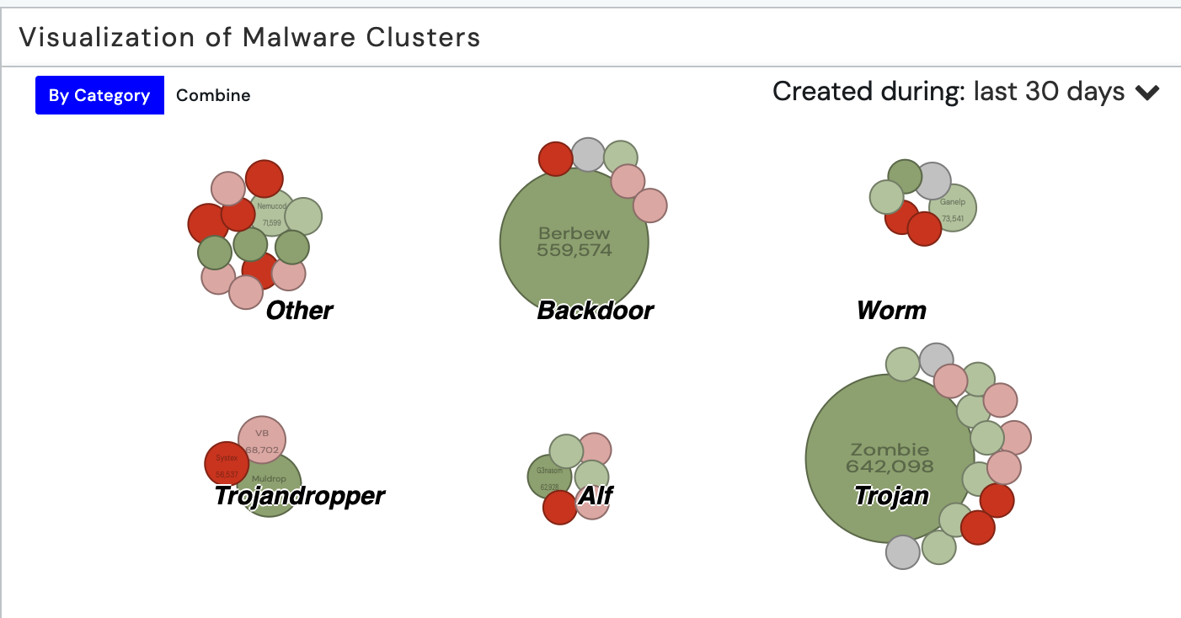
Trojan:Win32/Zombie – 642,098 Count
Description: Trojan:Win32/Zombie is a malware family that disguises itself as legitimate software to trick users. Once executed, it can perform various malicious actions on the system.
Impact: Enables unauthorized access, data theft, and system compromise.

Worm : Win32/ Ganelp - 73,541 Count
Description: Win32/Ganelp is a worm that spreads across systems and networks without user interaction, often exploiting vulnerabilities or removable media.
Impact: Can self-replicate, infect multiple systems, and facilitate malware delivery or other malicious actions.

TrojanDropper:Win32/MulDrop – Activity Overview
Description: TrojanDropper:Win32/MulDrop is a malware designed to install additional malicious software onto an infected system while avoiding detection.
Impact: Can deploy multiple malware payloads, compromise system integrity, and facilitate further attacks.

Trojan:Win32/G3nasom (Alf) – Activity Overview
Description: Trojan:Win32/G3nasom, also known as Alf, is a malware that executes malicious actions on the infected system, often disguised as legitimate software.
Impact: Can steal data, compromise system integrity, and potentially download additional malware.

TrojanDownloader:Win32/Nemucod – Activity Overview
Description: TrojanDownloader:Win32/Nemucod is a malware that downloads and installs additional malicious software onto an infected system, often bypassing security measures.
Impact: Can deploy ransomware, trojans, or other malware, compromise system integrity, and enable further attacks.
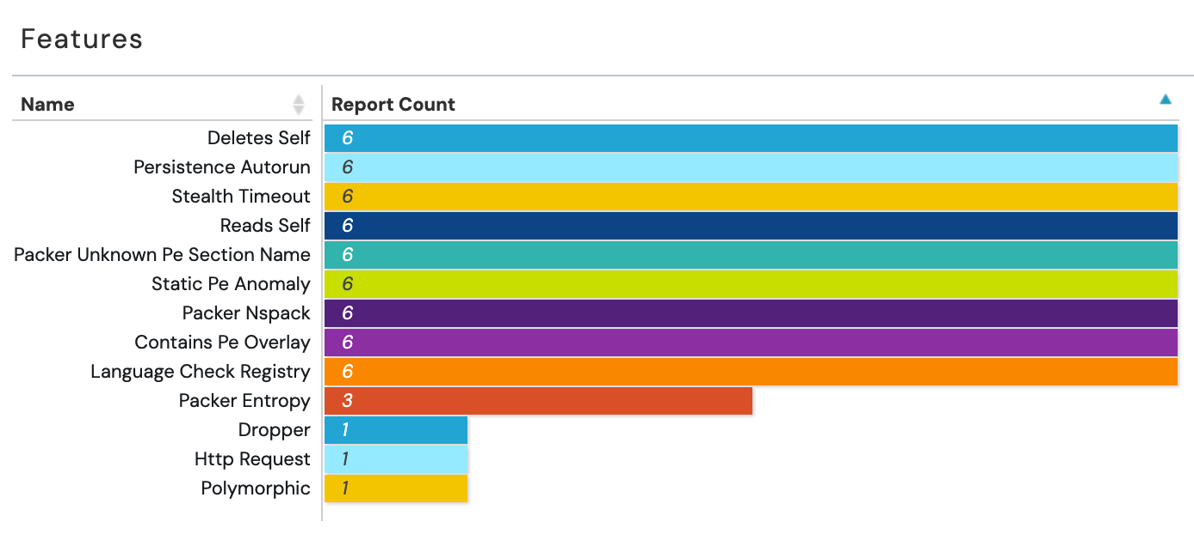

Indicator Type | Indicator Value | Adversary | Affected Industries/Regions | MITRE ATT&CK Techniques | Key IOCs
URL | archive.ph | Not specified | Global (potentially all sectors) | T1071.001 | None listed
Malware Family | Berbew, Paragon, Graphite, Pegasus, Mirai, Endgame 4 | Not specified |  | T1071.001 | None listed
URL | goodreads.com | Not specified | Global (potentially all sectors) | T1071.001 | None listed
Malware Family | Pegasus | Not specified | Global (potentially all sectors) | T1071.001 | None listed
Final Observation:
- archive.ph – Even though no specific IOCs are listed, the URL’s potential misuse for hosting phishing pages or malware demonstrates that caution is required when handling such web archiving services.
- Berbew, Paragon, Graphite, Pegasus, Mirai, Endgame 4 – These malware families show that known threats with signatures are reliably detected, but new variants could bypass detection, highlighting the need for behavioral analysis and multi-layered defenses.
- goodreads.com – The detection of suspicious activity associated with a legitimate website demonstrates that even trusted domains can be exploited, reinforcing the importance of reputation checks and contextual analysis.
- Pegasus / Brave browser – The presence of Pegasus spyware on Brave browser servers emphasizes that even security-focused software infrastructure can be compromised, underscoring the need for continuous monitoring, threat intelligence, and proactive mitigation strategies.

Objective 5 — Report on extra samples

File Sample 1 — QakBot (Malware)
I found a GitHub repo for QakBot malware with a known SHA-256 hash:
- Source: RanjitPatil/Qbot-Qakbot-Malware-Analysis
- SHA-256: f5c16248418a4f1fd8dff438b26b8da7f587b77db9e180a82493bae140893687

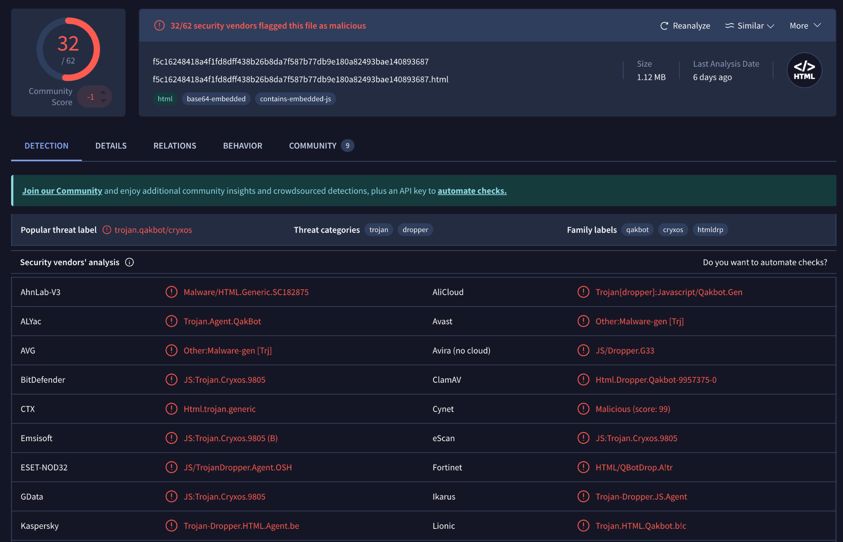
Community Score for QakBot : 32/62
32 vendors have classified this SHA256 hash as malicious.

Behaviour and Network Communication:
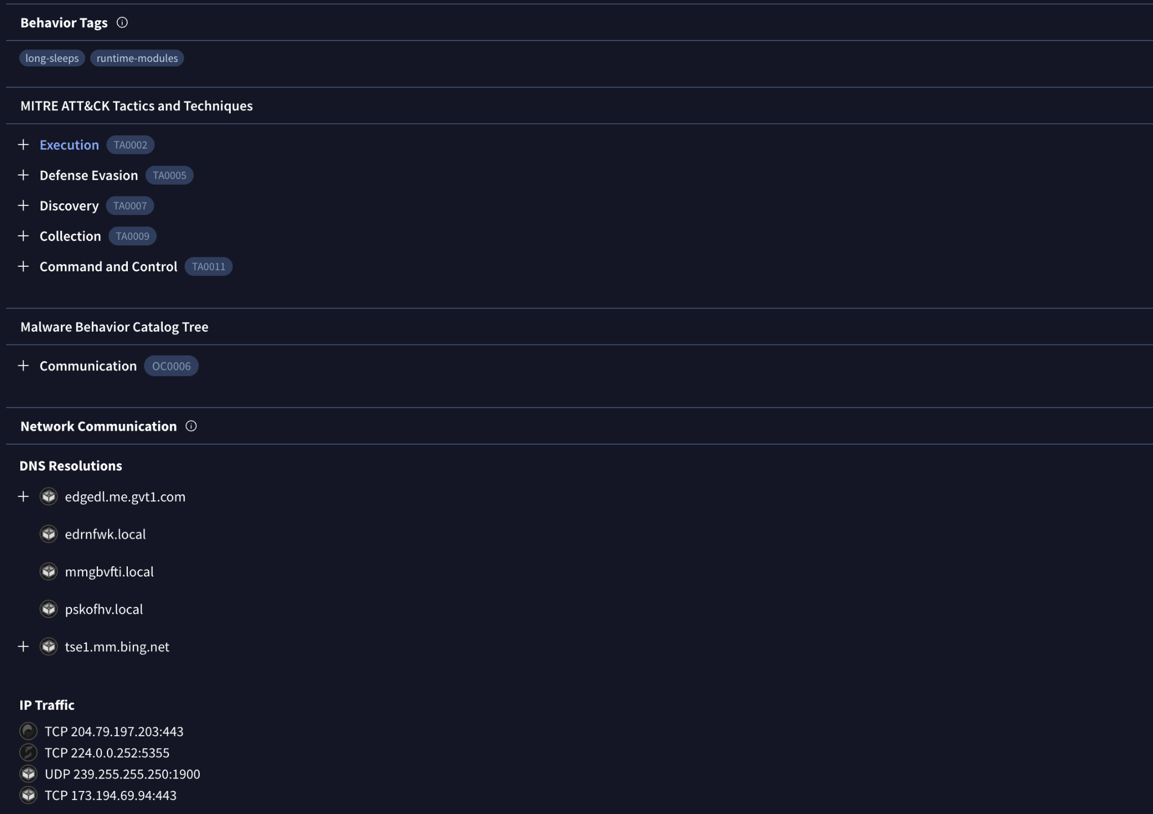
Contacted Domains / Contacted IPs / Dropped Data:
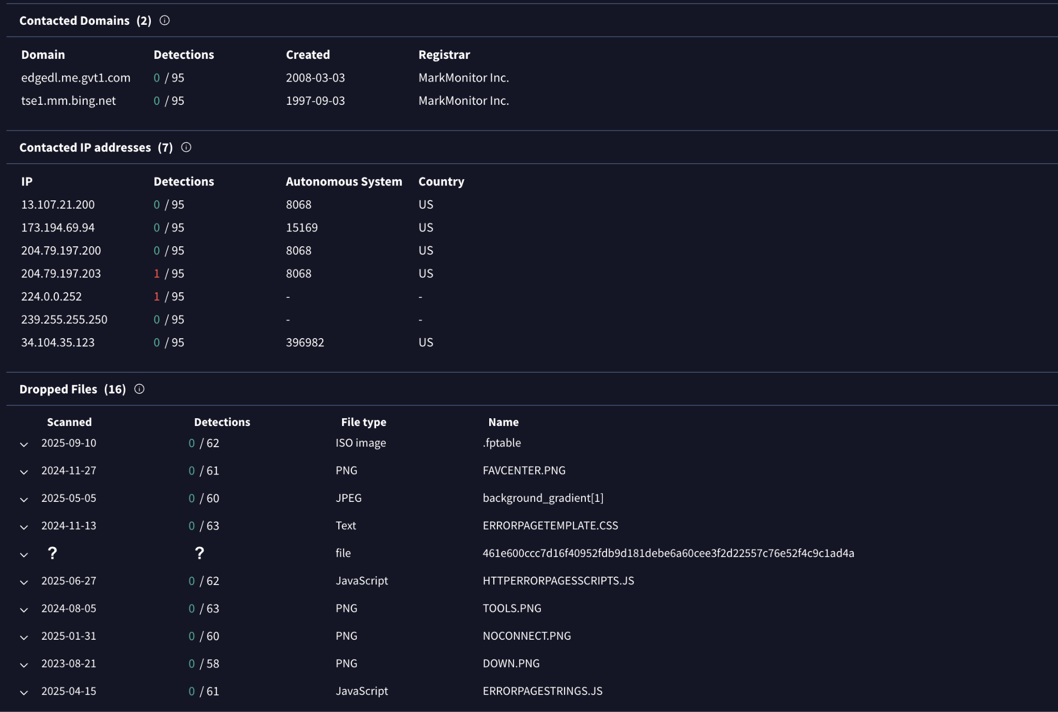

OBSERVATION:
- QakBot often blends with legitimate cloud/CDN infrastructure to hide its C2 traffic.
- Dropper Files: Mix of ISO images, PNGs, JavaScript, and CSS files.
Example names: .fptable (ISO), HTTPERRORPAGESSCRIPTS.JS, ERRORPAGESTRINGS.JS
These suggest malware loader components disguised as benign resources (e.g., images, error page scripts).

- Behavior Tags:
- long-sleeps → sandbox evasion tactic
- runtime-modules → dynamic loading of modules
- Abuses legitimate Microsoft/Google infrastructure to blend in
- Exhibits C2 communications consistent with QakBot operations
Therefore, QakBot is declared as HIGH RISK.

File Sample 2 — projectsouth.org ( Phishing URL)
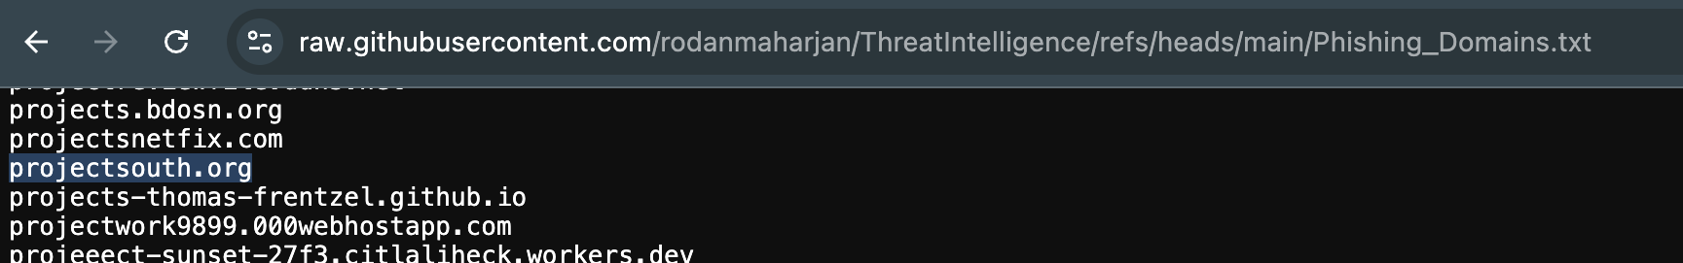
Firstly we will do WHOIS lookup on this domain to obtain general information about this URL.
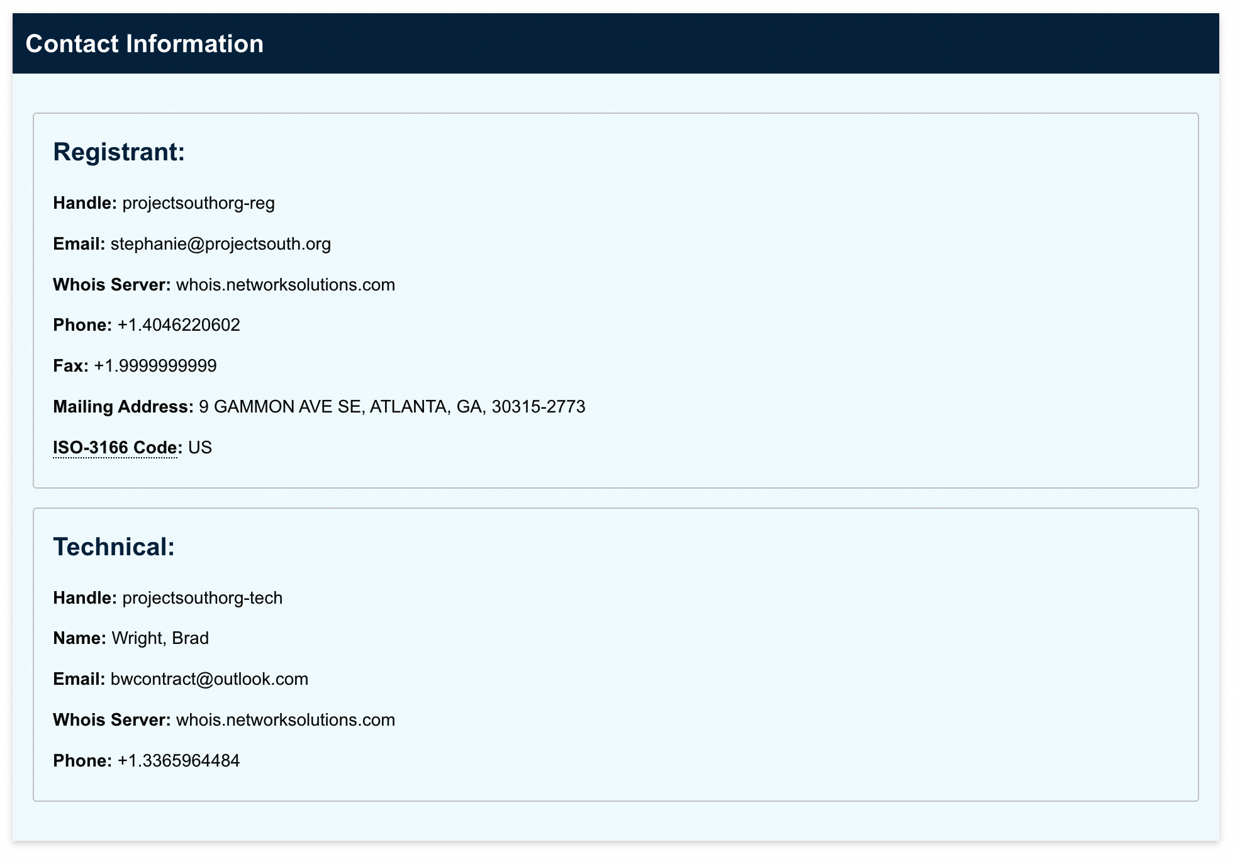
Domain Age: Established 1998 → long-standing, legitimate history.
Registrar: Network Solutions, LLC (IANA ID: 2).
Expiration: May 2029 (recently renewed, still active).
Email: stephanie@projectsouth.org
Location: Atlanta, GA, US
Contact: Brad Wright, bwcontract@outlook.com
- Domain transfer locked (clientTransferProhibited).
- DNSSEC not enabled → weaker DNS integrity protection.
Now, analyzing this domain on Virustotal.com and threatminer.org
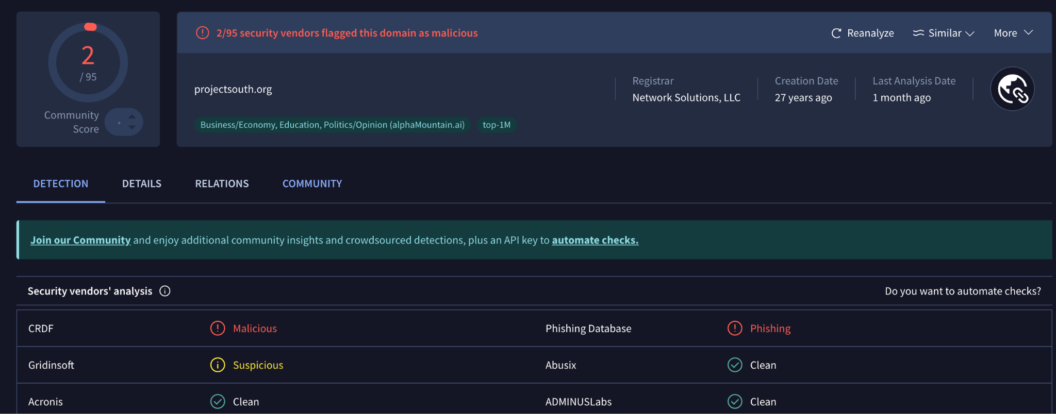
Community Score: 2/95
Vendor CRDF marked it as Malicious and it was also marked for phishing by Phishing Database. Mostly other vendors couldn't detect anything.

Assessment:
- Older malicious XML hits suggest historical compromise/abuse of the domain.
- Current references in PDFs and DOCX appear benign/activist content (no detections).
- Domain likely legitimate but at risk of being impersonated or abused in phishing/malware delivery campaigns.
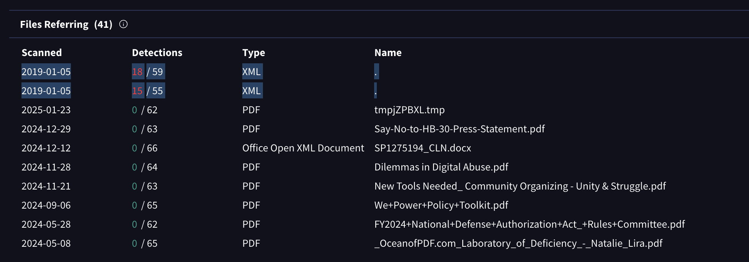
Afterwards I also attempted to check projectsouth.org on threatminer.org but it doesn't have any information on the URL in question.

Objective 6 — Endpoint threat hunt with OTX (free scan + agent)
- In OTX, run the free endpoint scan against known IOCs.
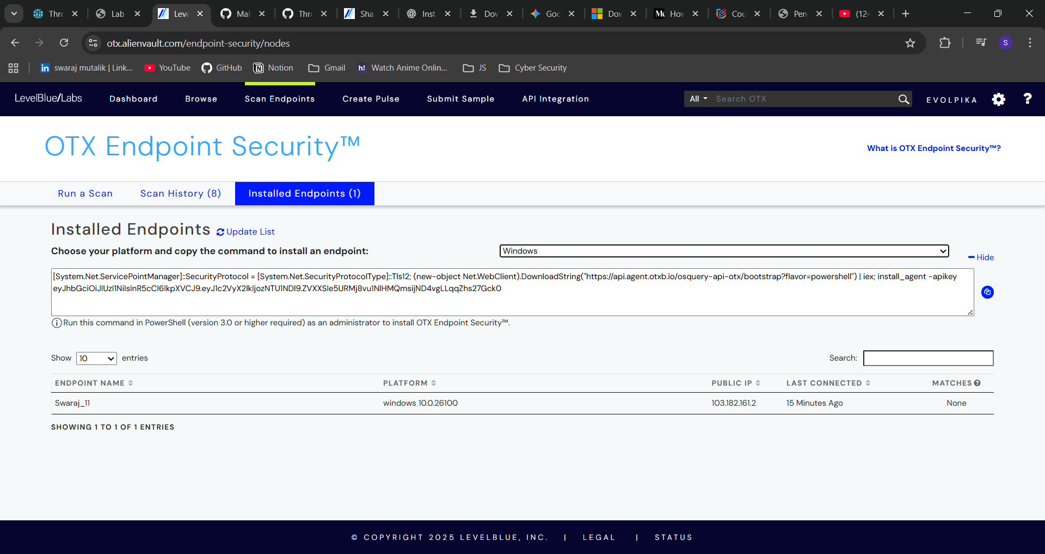
- Install the OTX Endpoint Agent on your VM: in your OTX account you’ll get a PowerShell one-liner with your API key/workspace—run that in an elevated PowerShell in the VM.
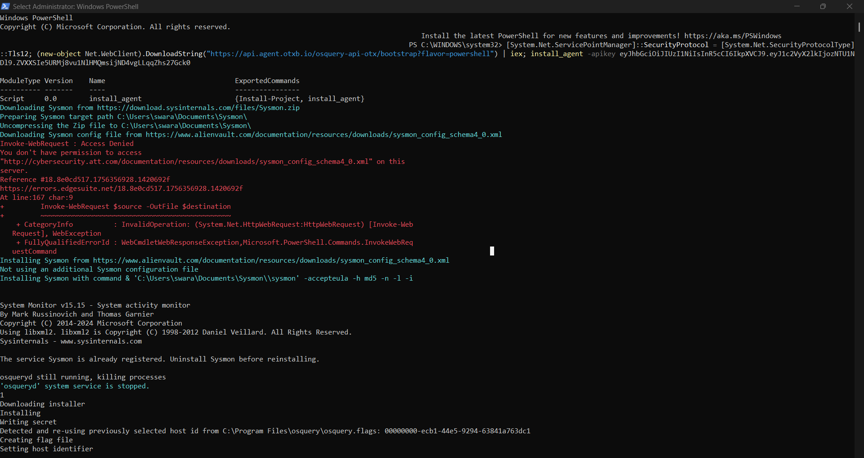
- After install, trigger a scan; capture detections/IOC matches.
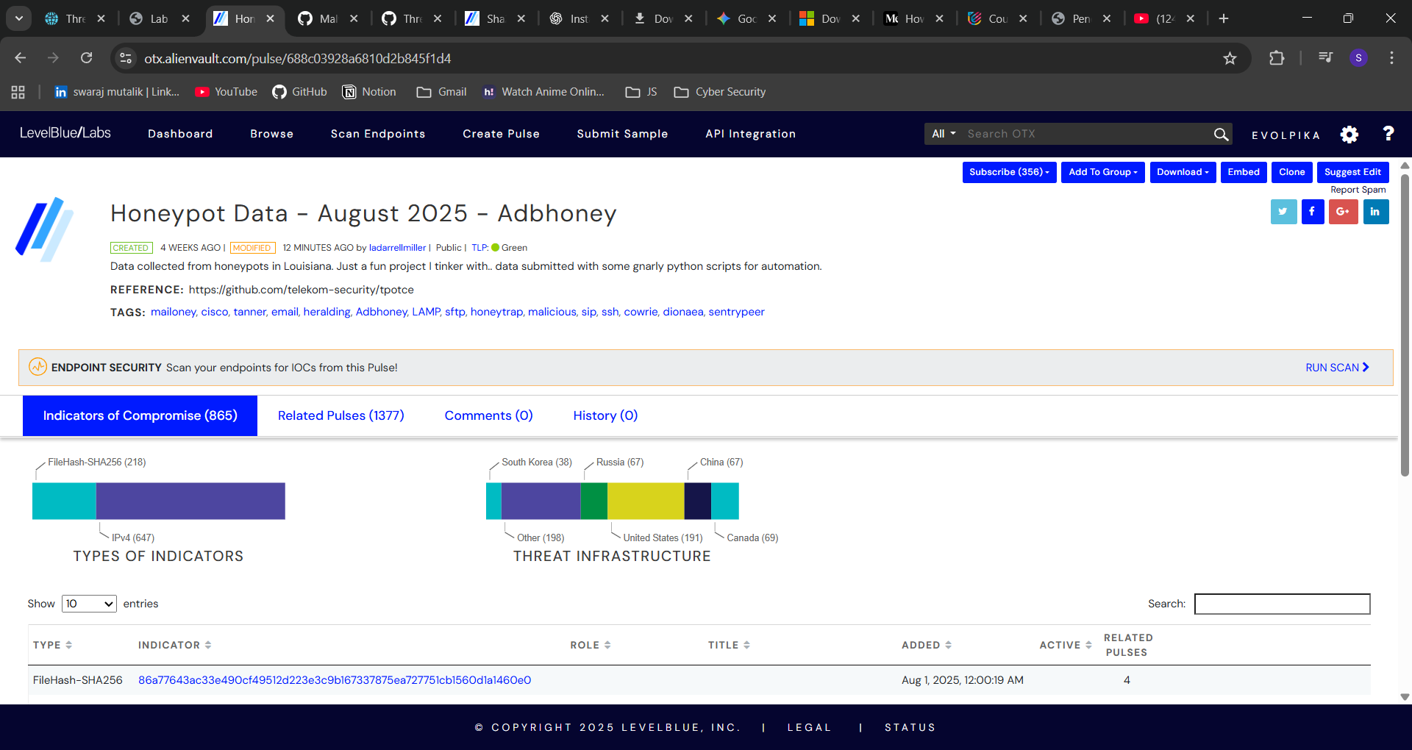
- Now we run the scan for the following pulse by clicking on the Run Scan option.
- Now we can see the results of the scan by looking at scan history and there we can look for the pulse that we gave for the scan.
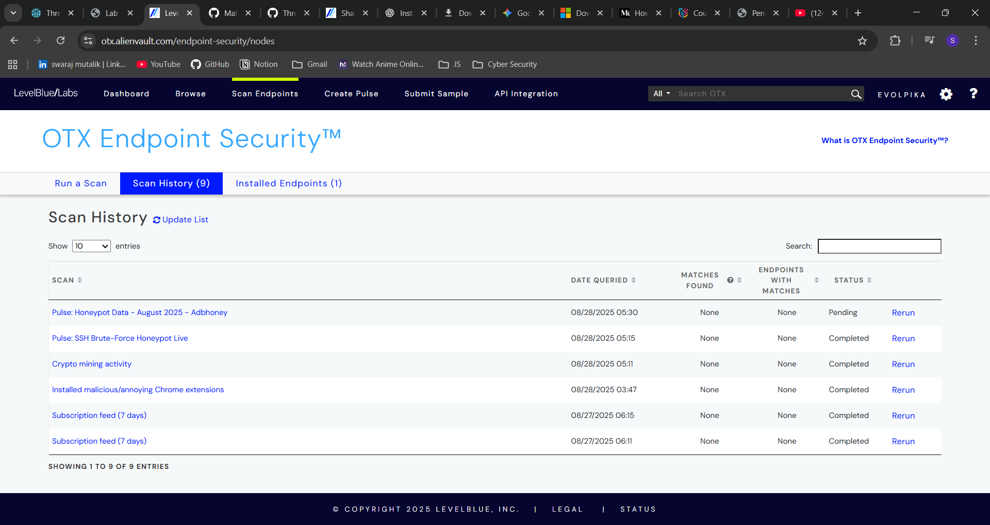

—-------------------------------END OF DOCUMENT -------------------------------------

